The Title Font: Times New Roman, Size: 20; Word Limit: 20, Centralized

Author’s information can not be included in the proceeding for double-blind review purpose.

ABSTRACT

Abstract should be in one paragraph, line spacing: double, Times New Roman, Size: 12. Number of words should be between 100 and 250. The abstract should include the background of the study, methodology, main findings, and the implications. The first line of abstract should be indented 0.5’’. Outline level: distributed.

KEYWORDS

Four to six keywords; keyword 1; keyword 2; keyword 3.

I. INTRODUCTION (Heading 1 should be bold)
The total length of the proceeding can not exceed 10 pages including everything. For the text: line spacing: double, Times New Roman, Size: 12. The first line of each paragraph should be indented 0.5’’. Outline level: distributed.
This template, modified in MS Word 2003 and saved as “Word 97-2003” for the PC, provides authors with most of the formatting specifications needed for preparing electronic versions of their papers.
Margins, column widths, line spacing, and type styles are built-in; examples of the type styles are provided throughout this document. Before you begin to format your paper, first write and save the content as a separate text file.
II. USE OF THIS TEMPLATE
2.1. Selecting a Template (Heading 2)
You should have a correct template for your paper size. This template has been tailored for output on the US-letter paper size. If you are using A4 size, please change it to letter size. The template is used to format your paper and style the text.
2.2. Maintaining the Integrity of the Specifications
All margins, column widths, line spaces, and text fonts are prescribed; please do not alter them. Insert page number at the bottom of pages.
2.3. Figures and Tables
Positioning Figures and Tables: Large figures and tables may span across pages. Figure captions should be below the figures; table heads should appear above the tables. Insert figures and tables after they are cited in the text. Use the abbreviation “Fig. 1”, even at the beginning of a sentence.

Table 1. Table Type Styles.
Table Head | Table Column Head
 | Table column subhead | Subhead | Subhead
copy | More table copy

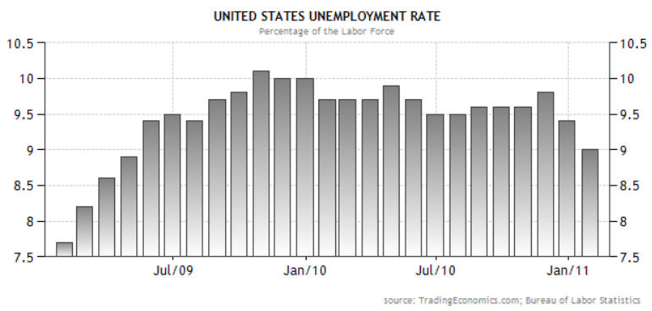
FIGURE 1. U.S. UNEMPLOYMENT RATE.

III. EQUATIONS
The equations are an exception to the prescribed specifications of this template. You will need to determine whether or not your equation should be typed using either the Times New Roman or the Symbol font (please no other font). To create multileveled equations, it may be necessary to treat the equation as a graphic and insert it into the text after your paper is styled. Number equations consecutively. Equation numbers, within parentheses, are to position flush right, as in (1), using a right tab stop. Punctuate equations with commas or periods when they are part of a sentence, as in
       

Be sure that the symbols in your equation have been defined before or immediately following the equation. Use “(1)”, not “Eq. (1)” or “equation (1)”, except at the beginning of a sentence: “Equation (1) is . . .”

Acknowledgment (HEADING 5)
The preferred spelling of the word “acknowledgment” in America is without an “e” after the “g”. Avoid the stilted expression, “One of us (R. B. G.) thanks . . .” Instead, try “R. B. G. thanks”.

IV. REFERENCES
Please use APA 6 edition format to make citations and list references. Listing sources of information at the end of a paper is an important part of professional scholarship and writing. It is highly suggested that all references should be check if they are complete: no missing or uncited references. The references should be listed in the alphabetic order of the last name of the first author. Refer to the author’s last name and published year in the parenthesis, as in (Cox and King, 2006) except at the beginning of a sentence: “Cox and King (2006) demonstrated . . .”
Unless there are more than six authors, give all authors' names; do not use “et al.” Papers that have been submitted for publication but not yet published should be cited as “unpublished.” Papers that have been accepted for publication should be cited as “in press.” Capitalize only the first word in a paper title, except for proper nouns and element symbols. For papers published in translation journals, please give the English citation first, followed by the original foreign-language citation.
Please refer to the following examples of citation formats for journals, conferences, books, electronic media, and magazine & newspaper articles.
1) Journal Articles
Foster Jr, S. T. (2008). Towards an understanding of supply chain quality management. Journal of Operations Management, 26(4), 461-467.
Lee, H. L., Padmanabhan, V., & Whang, S. (1997). Information distortion in a supply chain: The bullwhip effect. Management Science, 43(4), 546-558.
Mitra, S., & Webster, S. (2008). Competition in remanufacturing and the effects of government subsidies. International Journal of Production Economics, 111(2), 287-298.

2) Conferences Articles

Bourassa, S., ‘Effects of child care on young children’, Proceedings of the third annual meeting of the International Society for Child Psychology, International Society for Child Psychology, Atlanta, Georgia, 1999, 44-46.
Adelman, R., “‘Such Stuff as Dreams Are Made On’: God’s Footstool in the Aramaic Targumim and Midrashic Tradition,” Presented at the annual meeting for the Society of Biblical Literature, New Orleans, Louisiana, November 21–24, 2009.

3) Books

Foster Jr., S.T., Managing Quality: Integrating the Supply Chain, Prentice-Hall, Upper Saddle River, NJ, 2007.
Winston, W. and Albright, S.C., Practical Management Science (2nd ed.), Brooks/Cole, Pacific Grove, CA, 2001.
Jones, P.J., Smith, R. and Watson, E.P. (eds), Artificial Intelligence Reconsidered (2nd ed.), Wiley, New York, 1988.
Aronoff, G.R., Berns, J.S., Brier, M.E., et al., Drug Prescribing in Renal Failure (4th ed.), American College of Physicians, Philadelphia, PA, 1999.
Guyton J.L. and Crockarell, J.R., Fractures of Acetabulum and Pelvis, In Canale, S.T. (ed.), Campbell's Operative Orthopaedics (10th ed.), Mosby, Inc., Philadelphia, PA, 2003, 2939-2984.

4) Electronic Media

Devitt, T., “Lightning injures four at music festival,” The Why? Files, August 2, 2001, http://whyfiles.org/137lightning/index.html (accessed January 23, 2002).
Dove, R., “Lady Freedom among Us,” The Electronic Text Center, 1998, http://etext.lib.virginia.edu/subjects/afam.html (accessed June 19, 1998).
University of Georgia, "Points of Pride," University of Georgia, http://www.uga.edu/profile/pride.html (accessed October 21, 2009).
Kachru, B.B., “Norms, models and identities," The Language Teacher Online, 20(10), 1996, http://jalt-publications.org/tlt/files/96/oct/index.html (accessed October 25, 2001).

5) Magazine & Newspaper Articles

Henry, W.A., III., “Making the grade in today's schools,” Time, April 9, 1990, 28-31.
Kalette, D., “California town counts town to big quake,” USA Today, July 21, 1986, A1.

